Use-Case Realization Report (Analysis)
Update MCQ

Issue 1.0
Revision History
Date | Issue | Description | Author
01/Aug/09 | 1.0 | First Issue | Thomas Yap

Table of Contents
1. Brief Description 4
2. Flow of Events 4
2.1 Standard Flow 4
2.1.1 Update MCQ 4
2.2 Exception 4
3. Interaction Diagrams 5
3.1 Collaboration for Update MCQ 5
4. Participating Objects 5
5. Class Diagrams 6
5.1 Class Diagram for Update MCQ 6
6. Derived Requirements 6

Use-Case Realization Report
Update MCQ

Brief Description
This use case enables the controller to update multiples choice question profile with its properties and parameters. It involves displaying the menu and form and search by searchstrings or list to update the data.

Flow of Events
The standard flow of events for this use case and any exceptions are described in the following subsections. The events are described in terms of Actors and Analysis Objects.

Standard Flow
This use case covers the MCQ Maintenance - Update MCQ. The standard flow of these events are described below.

Update MCQ
The running of the application is shown in section 3.1. The flow of event is as follow:

- When the application start, the first operation to be performed is the startup operation of the main controller. This operation will create all the control objects and the entity objects necessary for operation Update MCQ:
  - The control object created is: MCQ Controller
  - The entity objects create are: MCQ Table and Transaction Record

- The main controller will start the main function menu:
  - To start Update MCQ, operation FormDisplayMCQ is activated by MCQ Controller to display a MCQ form.
  - Use Case Display MCQ List will retrieve a title list of MCQ for Portal Admin to pick to be display on FormDisplayMCQ.
  - The use can then choose the object to modify. He/she will be redirected to the formMaintenance
  - Operation validate will validate the format of the entries.
  - Then MCQ Controller will check for additional criteria if any.
  - After the record is found and display on FormDisplayMCQ, Portal Admin is to change any details in the form. A confirmation request will be sent to the FormDisplayMCQ interface. Upon confirmation, the record will then be updated to file using operation update to entity object MCQ Table.
  - In addition, a transaction log of user and date will be recorder by operation insertRecord
  - The adding request can be cancelled and no data will be altered. In this case, a transaction record will still be created for traceability.
  - A confirmation message will be displayed by FormDisplayMCQ interface.

- Step 2 will be repeated until all updates are completed. Then controller will terminate the application by issuing operation close.

Exception
None.

Interaction Diagrams

Collaboration for Update MCQ
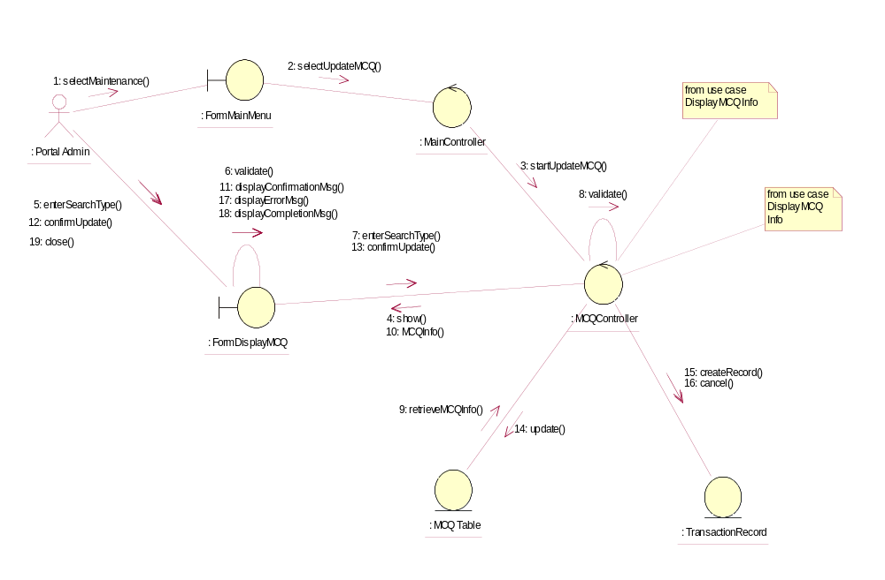

Participating Objects
: FormDisplayMCQ
This object is the interface for displaying MCQ details search activities.

: FormMainMenu
This is the main menu at the beginning of the application from where it can access the MCQ Maintenance - Update MCQ operation.

: MainController
This is the main controller that control the whole system.

: MCQ Table
This table stores all the properties and parameters of exam or exercise questions.

: MCQController
This is the controller for MCQ Maintenance. It creates and activates FormDisplayMCQ interface and MCQ Table.

: Portal Admin
This is the only actor that authorized to perform operation MCQ Maintenance - Update MCQ.

: TransactionRecord
This is the entity object that created for transaction log and audit trail.

Class Diagrams

Class Diagram for Update MCQ
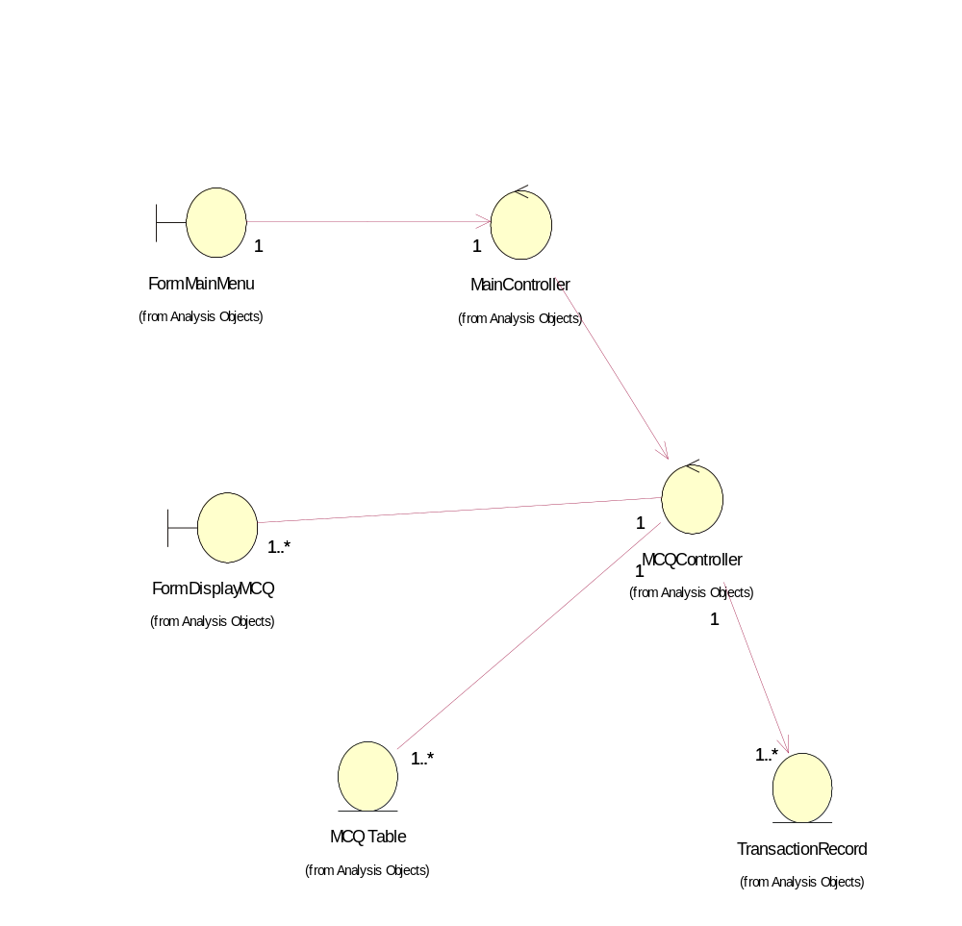

Derived Requirements
The FormMainMenu and FormDisplayMCQ Interface should have the format specified in User Requirements Specification for Content Management Portal.

